美声骨架尺寸图：
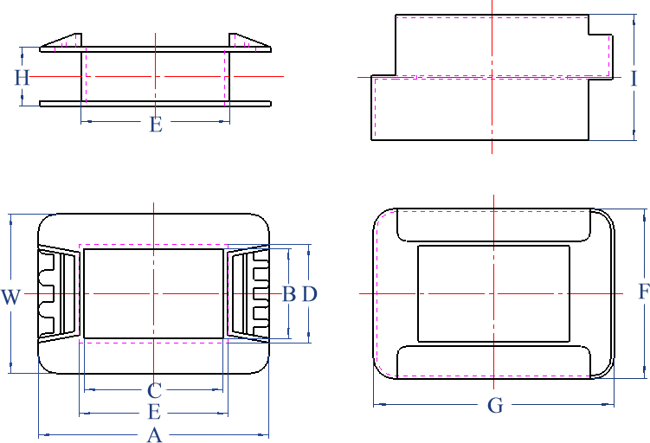
图一：抽屉式骨架
EI抽屉式骨架尺寸(图一)： 单位：MM
型号 | 规格 | B | C | W | A | D | E | H | F | G | I
C24-9 | 6×9 | 6.2 | 9.1 | 17.7 | 23.6 | 7.3 | 10.2 | 4.8/6.3 | 19.1 | 26.1 | 12.4
C28-12 | 8×12 | 8.3 | 12.2 | 18.3 | 26.7 | 9.5 | 14.4 | 6.3/8.2 | 19.9 | 28.4 | 17.0
C28-12-2 | 8×12-2 | 8.3 | 12.1 | 18 | 26.6 | 9.6 | 13.2 | 7.3 | 19.9 | 29.7 | 16.4
C35-11 | 10×11 | 10.1 | 11.1 | 22.7 | 26.6 | 11.6 | 12.6 | 8.9 | 24.5 | 29.4 | 19.2
C35-13 | 10×13 | 10.2 | 13.2 | 22.6 | 29.6 | 12.0 | 15.6 | 8.6 | 24.8 | 32.0 | 19.3
C35-15 | 10×15 | 10.4 | 15.2 | 22.8 | 31.2 | 11.9 | 16.7 | 8.6 | 24.5 | 33.8 | 18.7
C35-18 | 10×18 | 10.4 | 18.4 | 23.4 | 35.5 | 11.9 | 20.2 | 8.9 | 24.5 | 38.4 | 19.2
C35-20 | 10×20 | 10.4 | 20.5 | 23.2 | 35.6 | 12.0 | 21.9 | 8.9 | 24.5 | 38.4 | 19.2
C41-11 | 13×11 | 13.5 | 11.5 | 26.5 | 28.0 | 14.9 | 12.9 | 9.5 | 28.4 | 30.4 | 20.7
C41-13 | 13×13 | 13.5 | 13.5 | 26.4 | 33.9 | 15.1 | 17.1 | 9.5 | 28.2 | 36.1 | 20.4
C41-14 | 13×14 | 13.5 | 14.5 | 26.4 | 34.0 | 15.1 | 17.1 | 9.5 | 28.2 | 36.1 | 20.4
C41-17 | 13×17 | 13.5 | 17.5 | 26.4 | 33.9 | 15.1 | 19.1 | 9.5 | 28.2 | 36.1 | 20.4
C41-19 | 13×19 | 13.4 | 19.3 | 26.7 | 37.4 | 15.1 | 22.0 | 9.6 | 28.7 | 40.5 | 20.8
C41-20 | 13×20 | 13.5 | 20.5 | 26.8 | 36.7 | 15.6 | 22.9 | 9.5 | 28.7 | 40.5 | 20.8
C41-25 | 13×25 | 13.4 | 25.4 | 26.2 | 41.4 | 15.3 | 27.1 | 9.4 | 28.8 | 44.1 | 20.9
C41-27 | 13×27 | 13.4 | 27.5 | 27.1 | 43.8 | 15.0 | 29.3 | 9.4 | 28.5 | 46.3 | 20.6
C41-40 | 13×40 | 13.2 | 40.1 | 26.7 | 56.1 | 14.9 | 41.6 | 9.6 | 28.5 | 59.6 | 20.6
C48-18 | 16×18 | 16.1 | 18.5 | 29.1 | 36.6 | 18.0 | 21.7 | 10.8 | 30.9 | 38.7 | 22.8
C48-20 | 16×20 | 16.3 | 20.2 | 29.3 | 36.6 | 18.1 | 22.1 | 10.7 | 31.1 | 38.8 | 23.3
C48-22 | 16×22 | 16.5 | 22.1 | 29.7 | 42.5 | 18.5 | 26.3 | 11.1 | 31.7 | 44.8 | 23.4
C48-24 | 16×24 | 16.6 | 24.3 | 29.9 | 42.4 | 18.6 | 26.2 | 11.0 | 31.6 | 44.8 | 22.8
型号 | 规格 | B | C | W | A | D | E | H | F | G | I
C48-26 | 16×26 | 16.5 | 26.3 | 30.0 | 47.0 | 18.3 | 28.3 | 10.8 | 31.7 | 50.8 | 23.3
C48-30 | 16×30 | 16.3 | 30.3 | 30.0 | 47.9 | 18.1 | 32.1 | 10.8 | 31.6 | 50.7 | 23.2
C48-35 | 16×35 | 16.6 | 35.1 | 29.7 | 53.3 | 18.8 | 37.5 | 10.8 | 31.5 | 55.1 | 23.3
C54-20 | 18×20 | 18.5 | 20.2 | 32.8 | 39.5 | 20.8 | 22.6 | 12.2 | 35.3 | 42.7 | 26.7
C54-25 | 18×25 | 18.5 | 25.2 | 32.8 | 44.3 | 20.8 | 27.5 | 12.2 | 35.3 | 47.7 | 26.8
C54-30 | 18×30 | 18.5 | 30.2 | 32.8 | 49.4 | 20.8 | 32.5 | 12.3 | 35.3 | 52.6 | 26.7
C57-19.5 | 19×19.5 | 19.6 | 20.0 | 35.3 | 41.8 | 21.6 | 22.5 | 13.0 | 37.4 | 44.0 | 27.5
C57-20 | 19×20 | 19.8 | 20.5 | 35.4 | 41.8 | 21.6 | 22.6 | 13.0 | 37.4 | 44.0 | 27.5
C57-25 | 19×25 | 19.6 | 25.5 | 35.7 | 45.8 | 21.4 | 27.3 | 12.9 | 38.1 | 49.4 | 27.8
C57-30 | 19×30 | 19.6 | 30.6 | 35.1 | 50.8 | 21.8 | 32.7 | 13.0 | 37.5 | 53.0 | 27.8
C57-35 | 19×35 | 19.6 | 35.6 | 35.3 | 57.0 | 21.8 | 38.2 | 13.0 | 38.1 | 60.0 | 27.8
C57-40 | 19×40 | 19.4 | 40.3 | 34.7 | 61.1 | 21.4 | 42.3 | 12.8 | 37.3 | 65.2 | 27.8
C60-25 | 20×25 | 20.5 | 25.1 | 37.1 | 47.7 | 22.7 | 27.2 | 13.5 | 39.5 | 51.8 | 28.8
C60-30 | 20×30 | 20.5 | 30.3 | 37.7 | 54.2 | 22.3 | 32.1 | 13.7 | 39.6 | 58.0 | 29.6
C66-25 | 22×25 | 23.0 | 25.4 | 41.0 | 47.6 | 25.3 | 27.6 | 14.9 | 43.1 | 50.7 | 31.7
C66-28 | 22×28 | 22.7 | 28.6 | 40.9 | 52.7 | 24.7 | 30.5 | 14.9 | 43.5 | 56.0 | 31.9
C66-30 | 22×30 | 22.4 | 30.1 | 40.1 | 51.9 | 24.8 | 34.3 | 14.7 | 43.3 | 55.7 | 31.7
C66-32 | 22×32 | 22.5 | 31.7 | 40.2 | 51.7 | 24.8 | 34.2 | 14.7 | 43.5 | 56.0 | 31.9
C66-33 | 22×33 | 22.5 | 33.6 | 40.9 | 60.4 | 24.3 | 37.4 | 14.8 | 43.1 | 62.6 | 31.6
C66-35 | 22×35 | 22.8 | 35.6 | 40.9 | 60.4 | 24.4 | 37.4 | 14.8 | 43.1 | 62.6 | 31.6
C66-35N | 22×35N | 22.2 | 34.8 | 40.1 | 58.6 | 24.4 | 37.0 | 14.8 | 42.9 | 62.5 | 31.5
C66-37 | 22×37 | 22.6 | 37.5 | 40.5 | 59.0 | 24.9 | 39.7 | 14.9 | 42.8 | 62.6 | 31.5
C66-38 | 22×38 | 22.6 | 38.1 | 39.8 | 64.8 | 24.3 | 42.8 | 13.7 | 42.7 | 67.8 | 31.5
C66-40 | 22×40 | 22.5 | 40.8 | 40.5 | 65.2 | 24.5 | 42.9 | 14.9 | 42.7 | 67.8 | 31.5
C66-44 | 22×44 | 22.7 | 44.2 | 40.7 | 70.3 | 24.7 | 47.2 | 14.8 | 43.5 | 74.4 | 31.6
C66-45 | 22×45 | 22.7 | 45.4 | 40.6 | 70.4 | 24.8 | 47.1 | 14.8 | 43.0 | 74.5 | 31.6
C66-50 | 22×50 | 22.3 | 50.1 | 40.8 | 75.8 | 24.7 | 52.3 | 15.0 | 43.4 | 79.0 | 32.5
C76.2-35 | 25.4×35 | 26.2 | 35.0 | 47.1 | 66.2 | 28.5 | 37.3 | 17.4 | 49.5 | 69.6 | 37.2
C76.2-40 | 25.4×40 | 26.5 | 40.6 | 47.5 | 74.2 | 29.1 | 44.7 | 17.6 | 50.1 | 77.3 | 36.4
C76.2-42 | 25.4×42 | 26.3 | 41.9 | 46.6 | 63.2 | 28.4 | 44.3 | 17.5 | 50.2 | 68.2 | 37.3
C76.2-45 | 25.4×45 | 26.5 | 45.6 | 47.1 | 73.4 | 29.0 | 48.0 | 17.7 | 50.1 | 77.3 | 36.4
C76.2-50 | 25.4×50 | 26.1 | 49.8 | 47.1 | 81.0 | 28.4 | 52.1 | 17.6 | 50.1 | 85.1 | 37.3
C85.8-45 | 28.6×45 | 29.4 | 45.4 | 52.7 | 72.3 | 31.4 | 47.5 | 19.1 | 55.3 | 79.7 | 41.1
C85.8-50 | 28.6×50 | 29.6 | 50.6 | 53.1 | 77.1 | 31.9 | 52.9 | 19.1 | 55.3 | 79.7 | 41.1
C85.8-55 | 28.6×55 | 29.7 | 54.5 | 53.9 | 87.6 | 32.2 | 57.3 | 20.0 | 56.6 | 91.8 | 42.2
C96-50 | 32×50 | 33.0 | 50.1 | 59.7 | 86.0 | 35.6 | 53.0 | 22.0 | 63.0 | 90.4 | 46.9
C96-55 | 32×55 | 33.0 | 55.3 | 59.4 | 86.3 | 35.5 | 57.9 | 21.8 | 63.0 | 90.4 | 46.9
联系电话：（0573）85188118 85188128 传真：（0573）85188138
E-mail:phms@phms.com.cn Http://www.phms.com.cn
欲了解更多，请访问美声网站：Http://www.phms.com.cn

